**PROJECT 2**

**COFFEESHOP MANAGEMENT**

**USER GUIDE**

1. User Interface
2. Login Form:

* If you want to use the application, you must login.

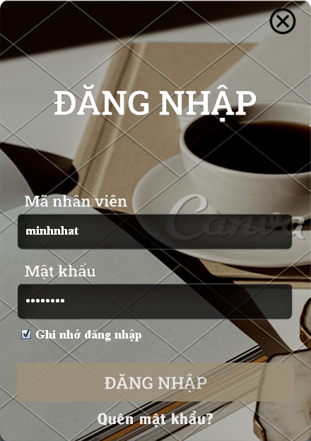

1. Order/Bills

* You can add order and export bills from here.

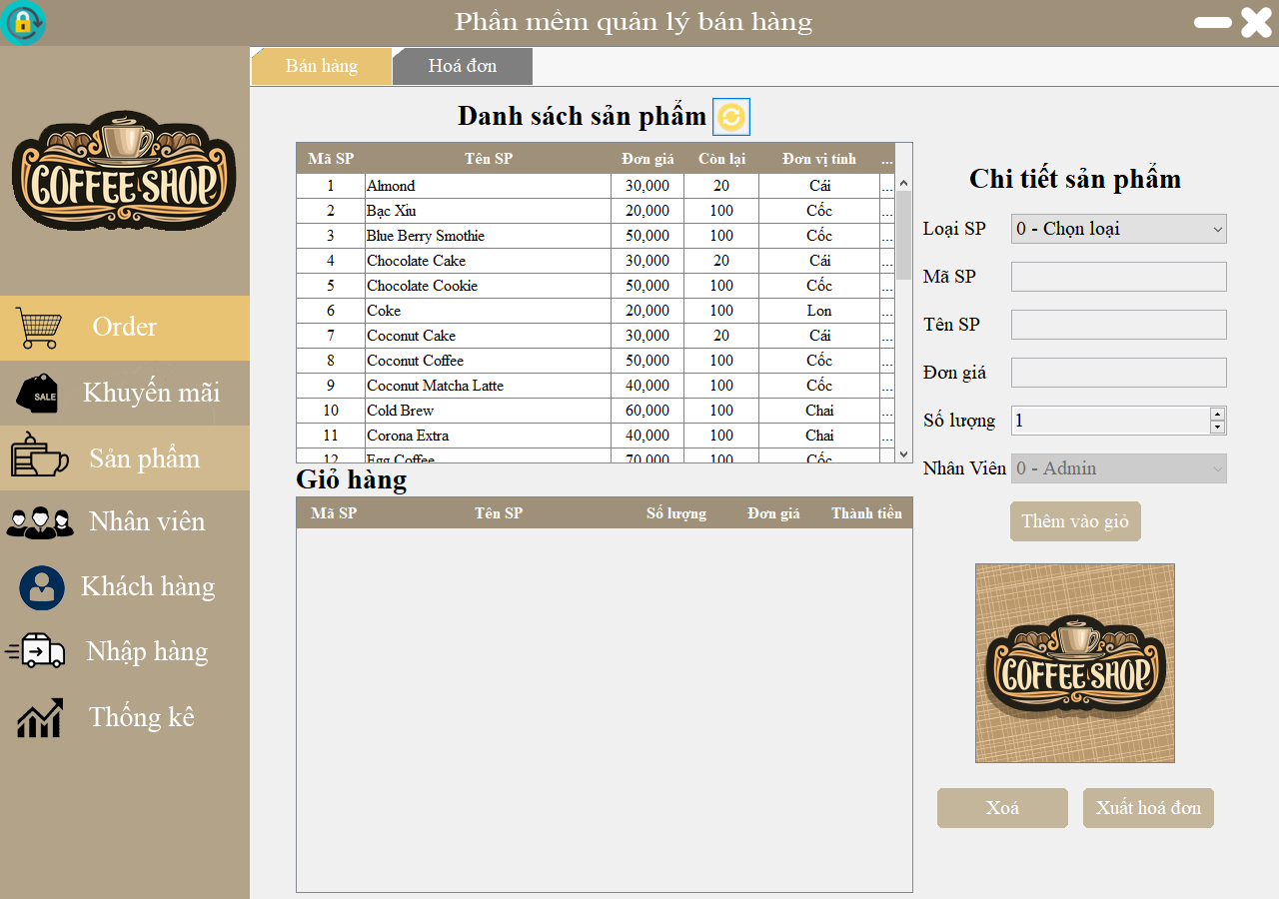

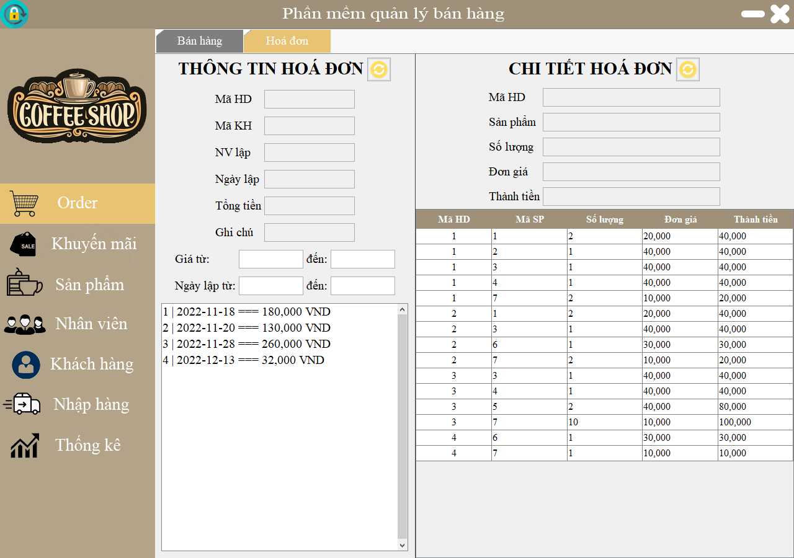

1. Promotion

* You can see all promotions.
* You can also create and modify any promotions you want.

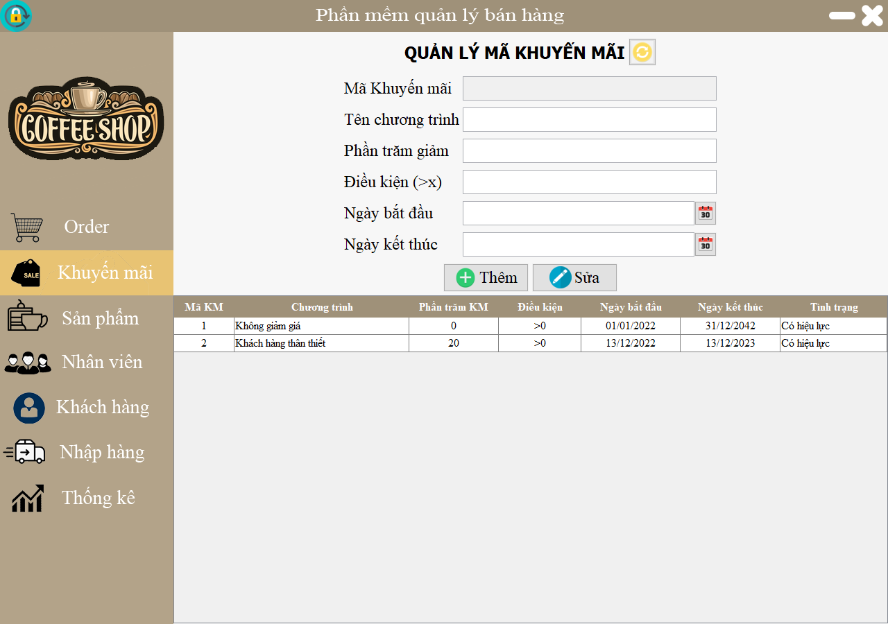

1. Product Detail Page:

* You can view product details.
* You can add, edit, delete, find the product. Also you can import and export the product from Excel files.

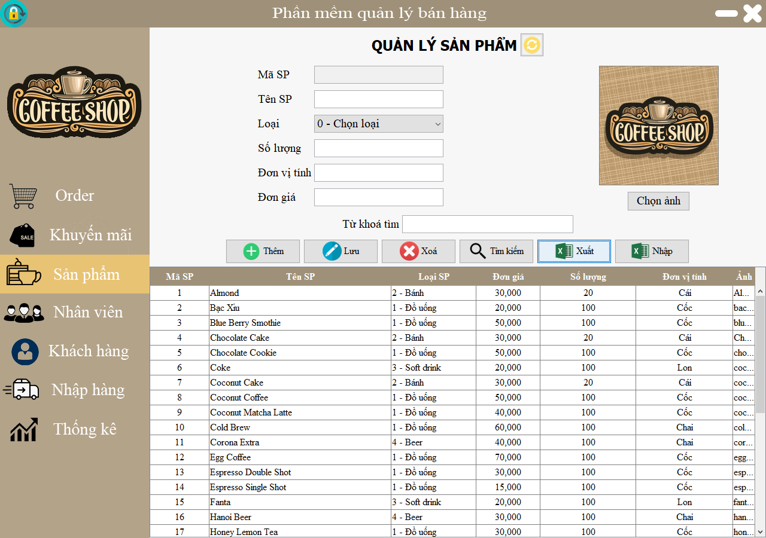

1. Staff

* There are 2 sections for this page:

+ First is staff section, where you can manage all your staffs.

+ Second is employee’s access, you can add new permission, edit the permission for your staff.

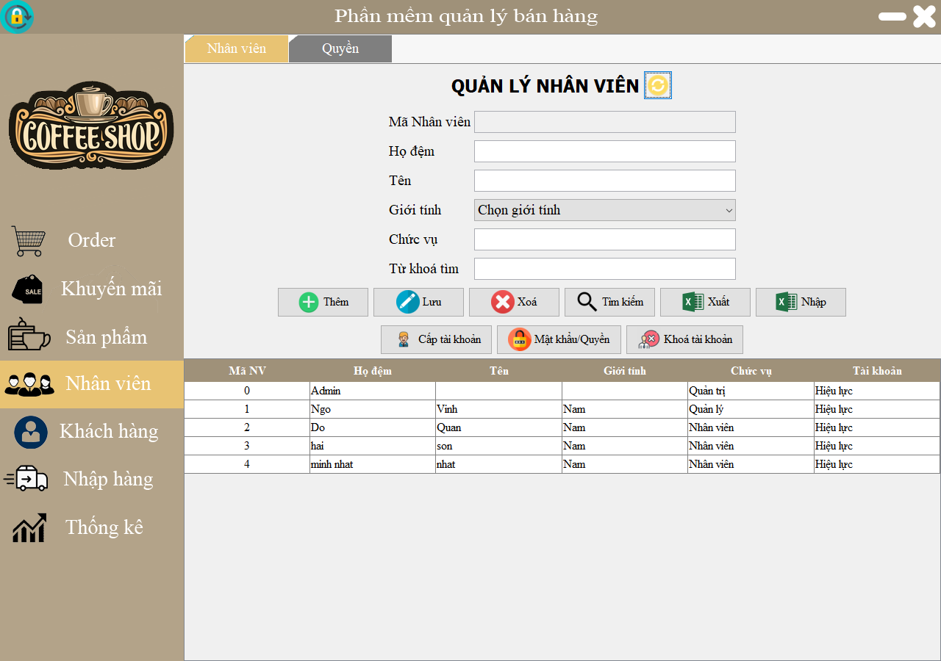

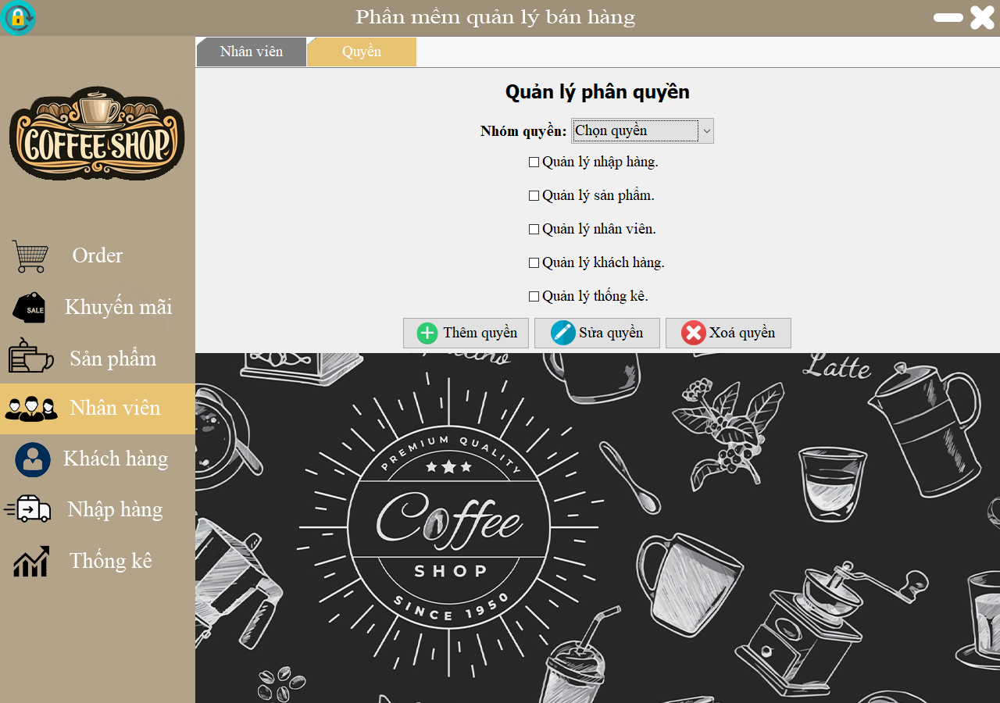

1. Customer Page:

* You can manage all customer’s information from here.

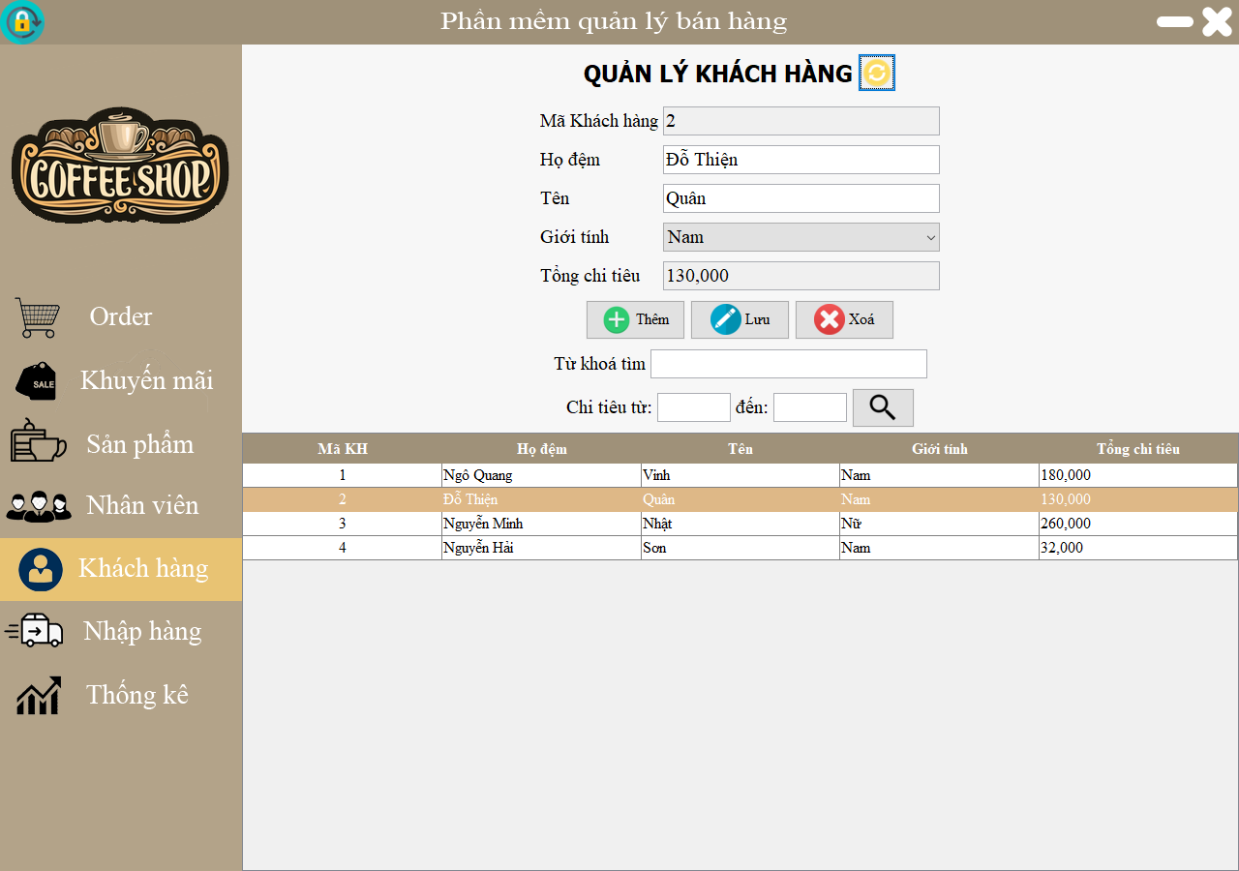

1. Import products:

* From this page you can import products that you need.

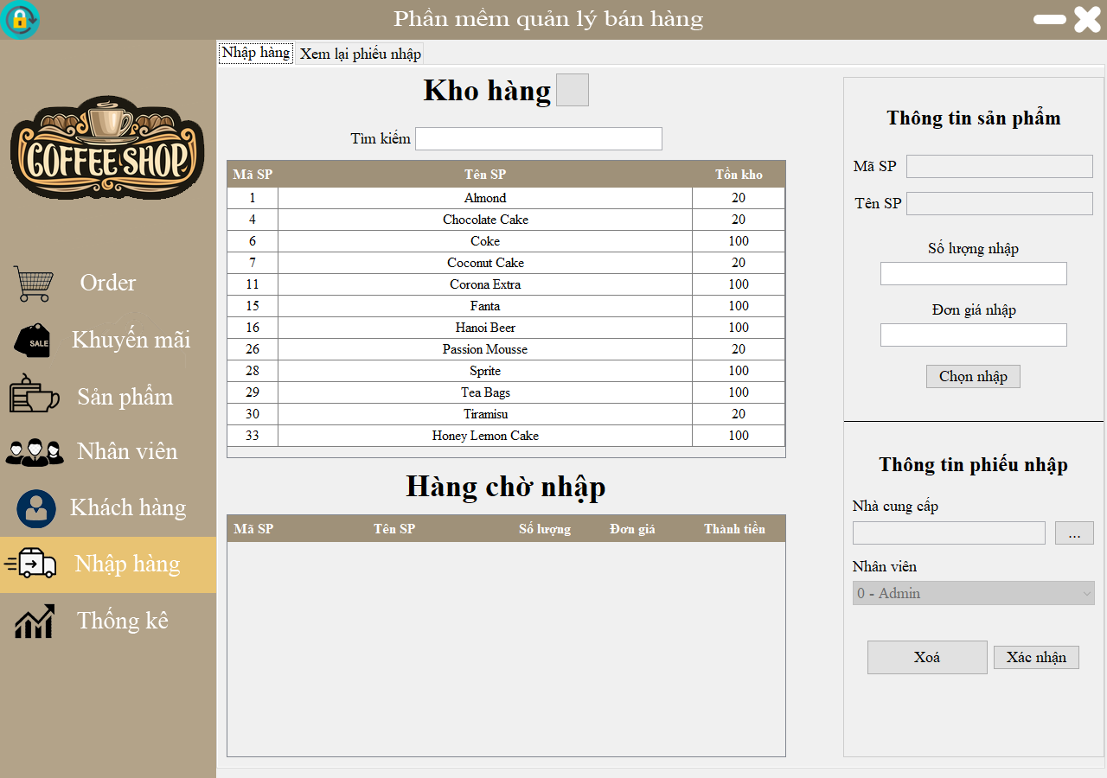

1. Statistical

* From this page you can see the data’s statistical.

